Monetisation Strategies.

Unity Ads

Unity Ads are built into the Unity Editor, where you can easily integrate them into your project. By default, Unity Ads only feature Video Ads and Reward Video Ads, but it also has support for Banner Ads (they’re just disabled to begin with).

This Ads can be monitored and set up through the Unity Developer Dashboard under the ‘Monetization’ tab.

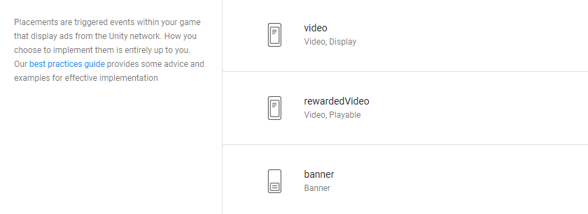

The Ads themselves can be tweaked in various ways. Both the Video and Reward Video Ads can be one of the following:

* Video – A Video is displayed
* Display – A still image is displayed
* Playable – An interactive advert is displayed (such as a vertical slice of a game)
* IAP – The game’s In App Purchases are displayed

The key difference between Videos and Reward Videos are that the later cannot be skipped. Therefore, according to the Unity Documentation, Developers are encouraged to grant a reward to users for watching these adverts. These adverts should be triggered by choice of the user, not mandatory.

Banner Ads in Unity do not have any of these options and are less easy to set up, as they must be set to a specific portion of the screen in the code first. Also, they do not provide as much revenue.

Google AdMob

Google AdMob is a Google Advertising API that displays advertisements to application users. This is a larger technical hurdle than Unity Ads, as it isn’t natively supported by Unity and has to be installed via a plugin located on GitHub.

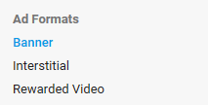Google AdMob provides Banner Ads, Interstitial Ads and Rewarded Video Ads. These are all very similar to the Unity Ads offerings (Interstitial is treated as a regular video ad) but it allows for greater Banner Ad customisation, such as allowing ‘Smart Banners’ to detect the screen size of the device and render accordingly, preventing low resolutions.